**Unit 6 Northwind Queries**

Corey Crooks

Purdue University Global

IT234 – Leon King

June 23, 2021

Problem 1: Display the product records with unit prices equal to or greater than $100. 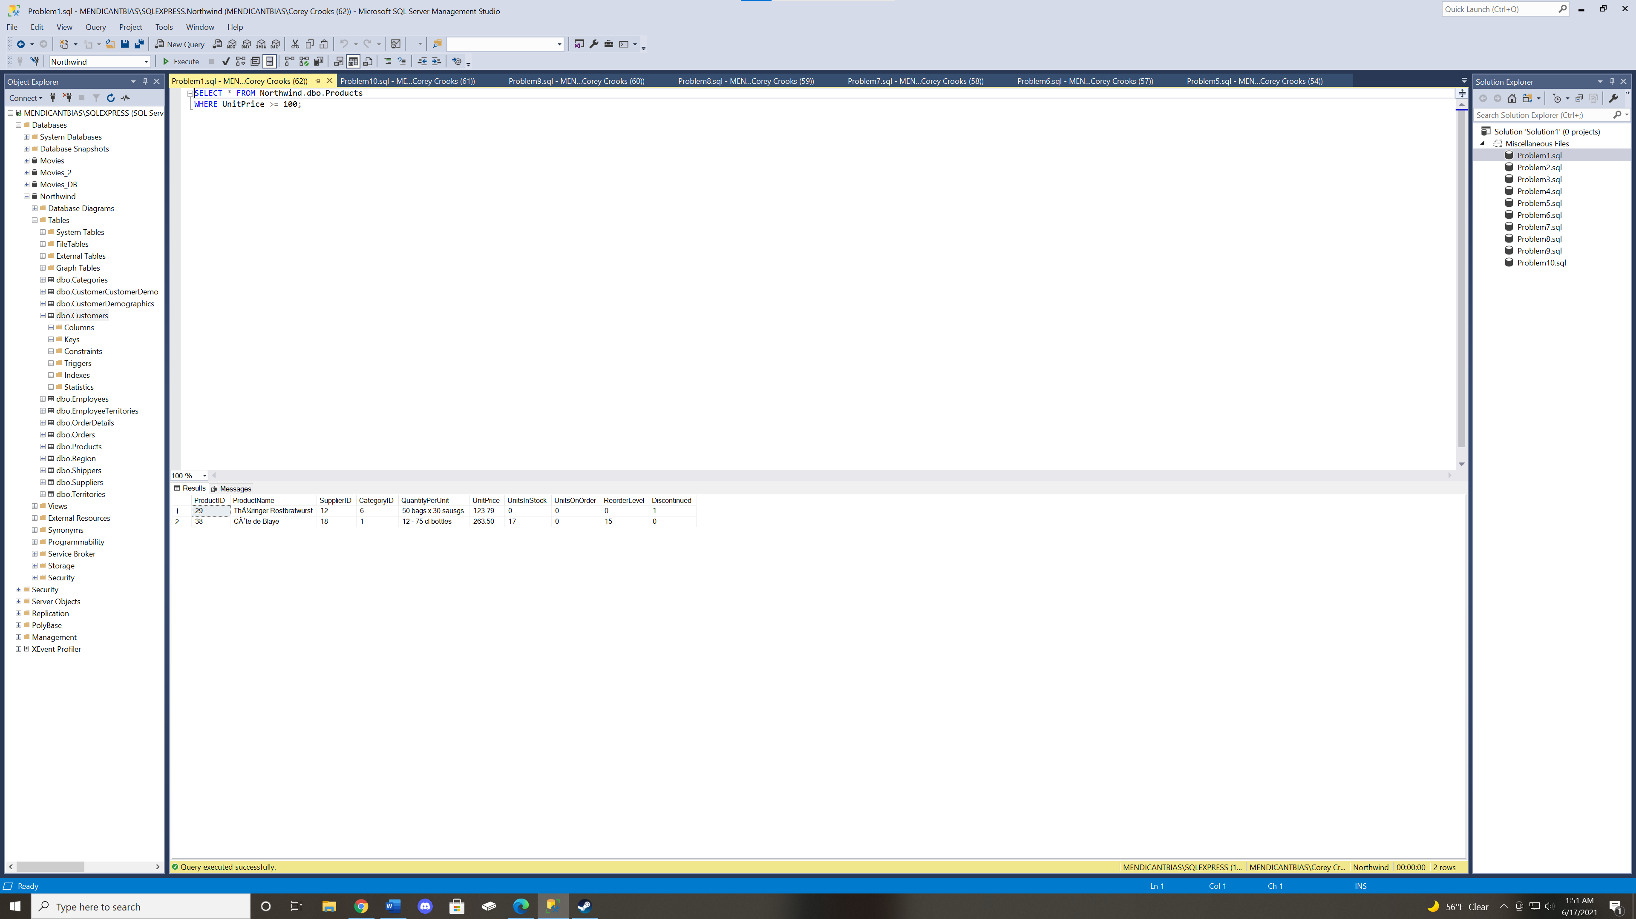

Problem 2: Present the unit value minimum, maximum, average, and standard deviation for current and discontinued products. Group the results based on the “Discontinued” attribute. 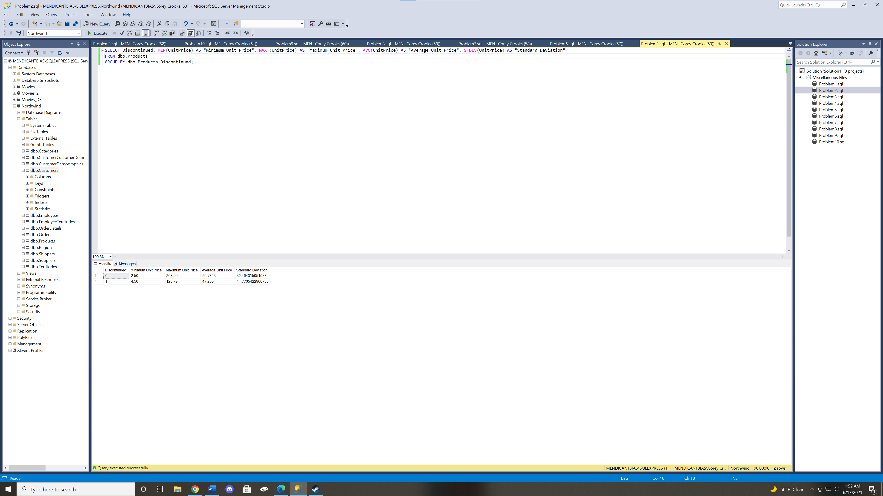

Problem 3: List suppliers with names starting with “G” in alphabetical order. 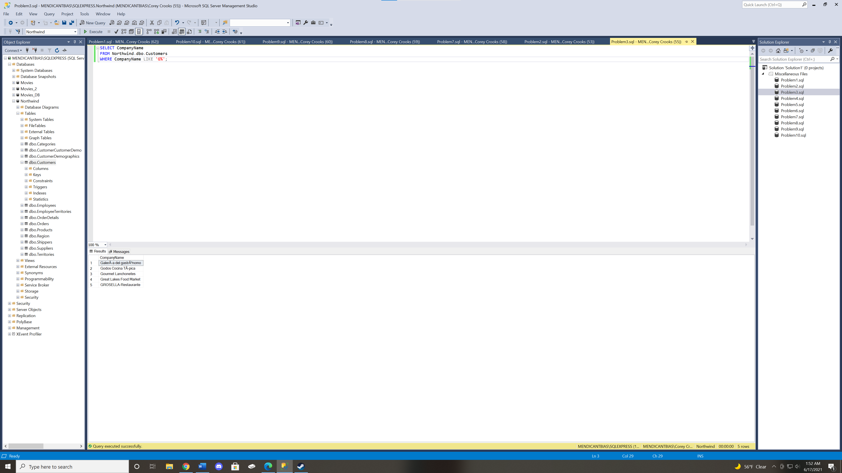

Problem 4: Display the full names of all Employees in FirstName, “ ” , LastName format. 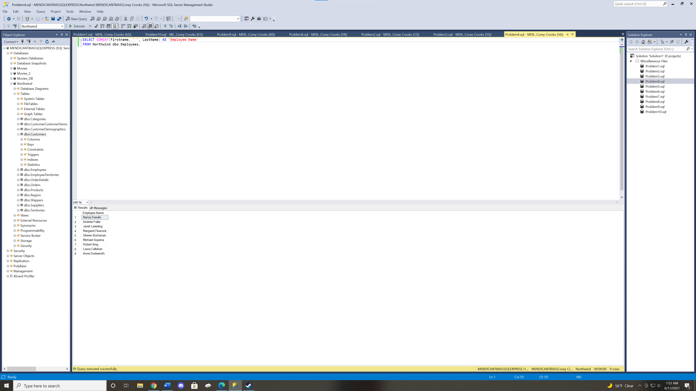

Problem 5: Display all of the supplier names and HomePage values where the HomePage value is null. Present the results in alphabetical order by supplier name. 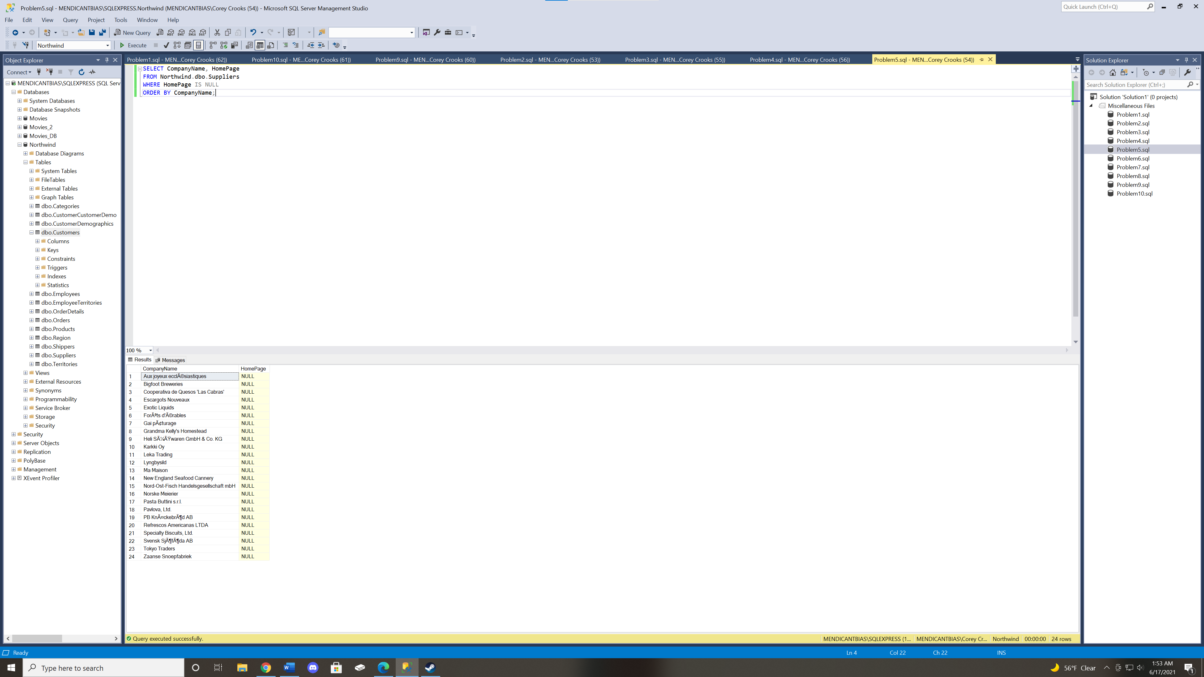

Problem 6: Get the number of Northwind customers in each country that has five or more customers. Present the results in alphabetical order by country name. 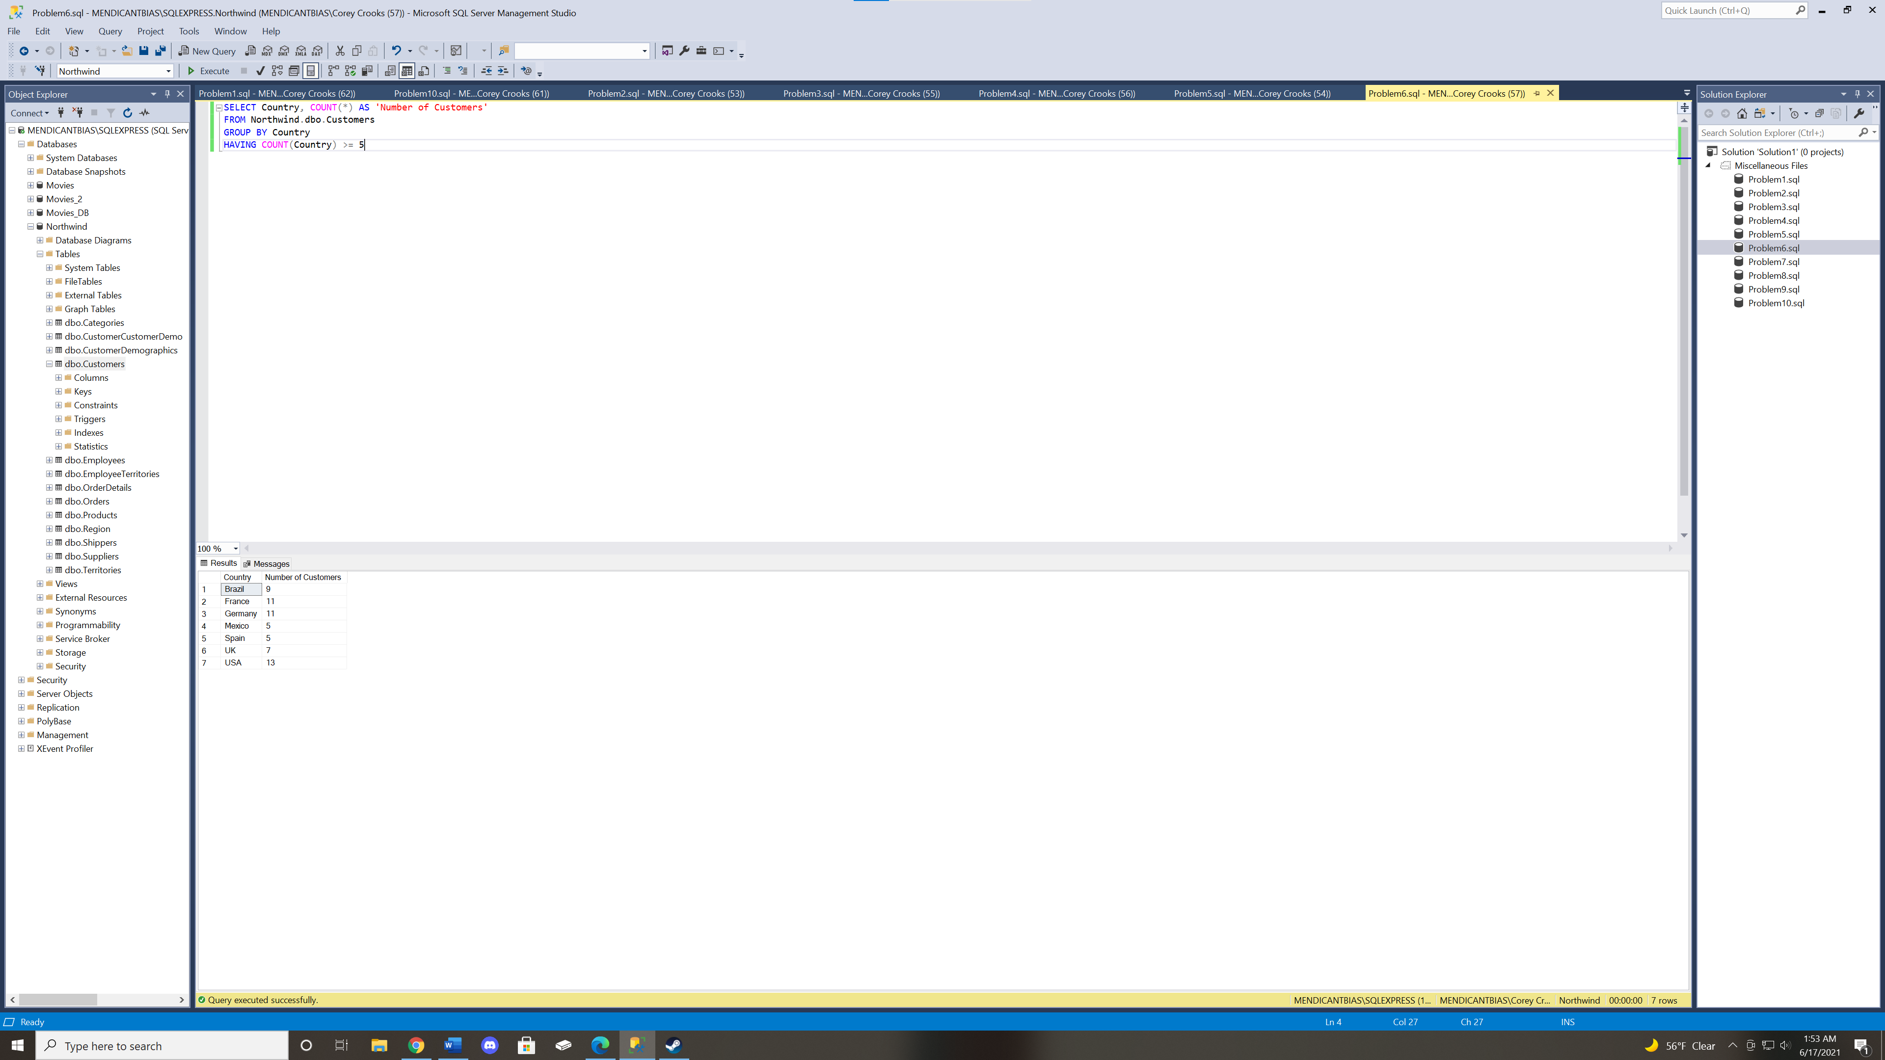

Problem 7: Get the total product costs (i.e., multiplying the unit price by quantity) for ProductID = 20 along with the associated orders IDs from the OrderDetails table. Provide the results in ascending order based on the order ID. 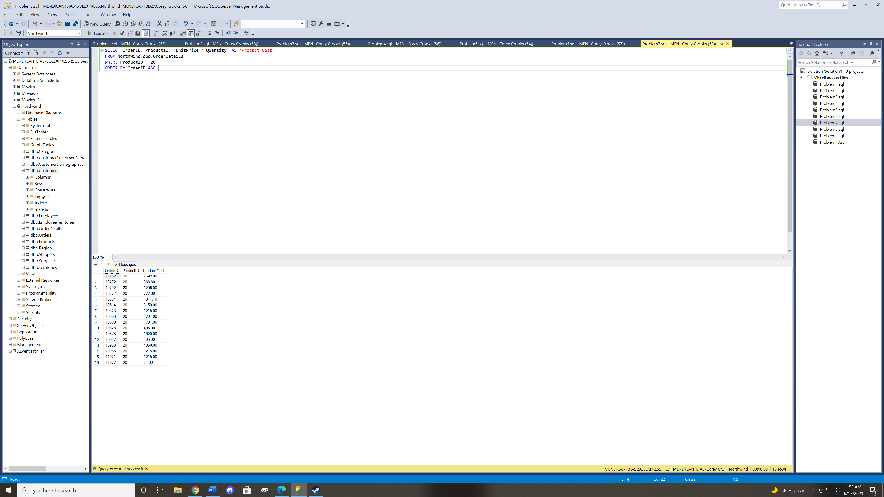

Problem 8: Select all of the cities where there are employees with no duplicate values displayed. Show the cities in alphabetical order. 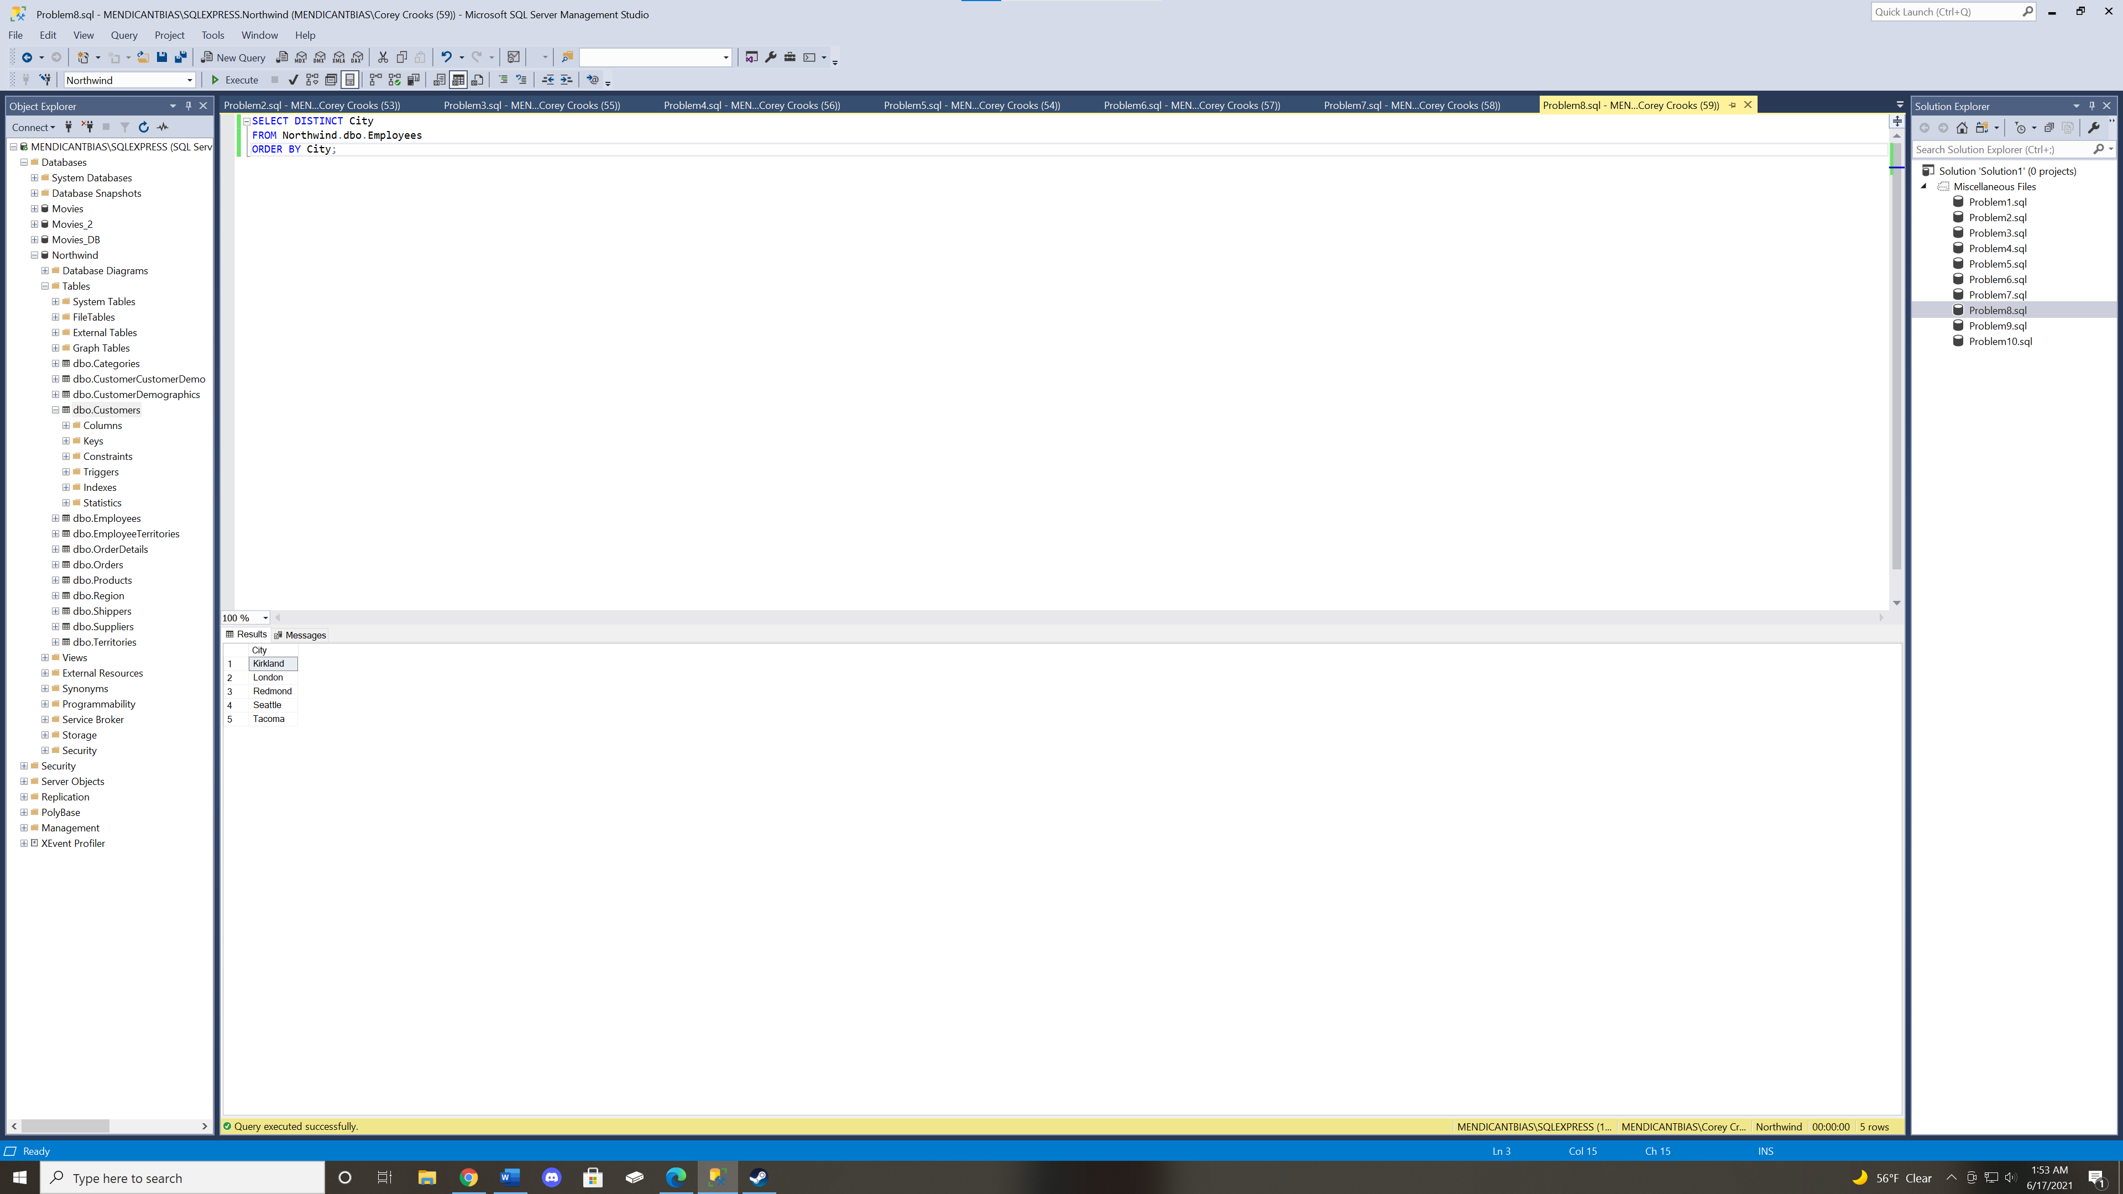

Problem 9: List first and last names for employees who live in London, Seattle, or Redmond. Show the employee’s city in the output. 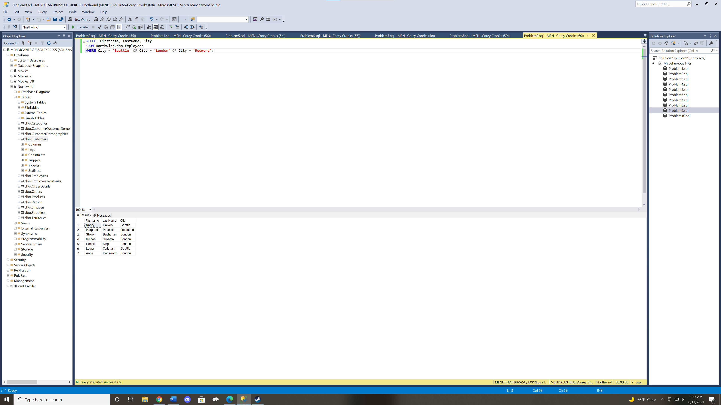

Problem 10: Display all product IDs and names for out-of-stock products having a unit price in the range of $20 to $25. Show the units-in-stock value in the results. 